TOUR ITINERARY*

Cost:
€ 120 per person twin share
€ 30 single room supplement; including breakfasts and dinners, guide and entry to all attractions.

DAY 1: Friday 8 July
07:00 - Departure from Istanbul.
09:30 - 10:00 Tarakli / Göynük town visits
Bolu – Ankara
15:00 - 15:30 Lunch break at the Orhan Ağaçlı service area at the crossroads of Aksaray
16:30 - Arrival at Cappadocia. (Total 675 km.)
Visits - Ürgüp and around
Dinner and stay at Mustafa Hotel, Ürgüp.

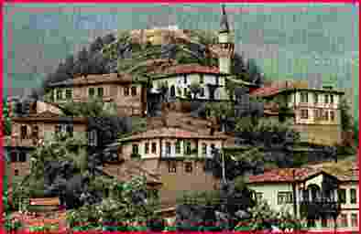
Taraklı, one of the oldest state in Sakarya which has historical background from B.C 2000 and is well known with the Ottoman houses and historical buildings from the 19th century.

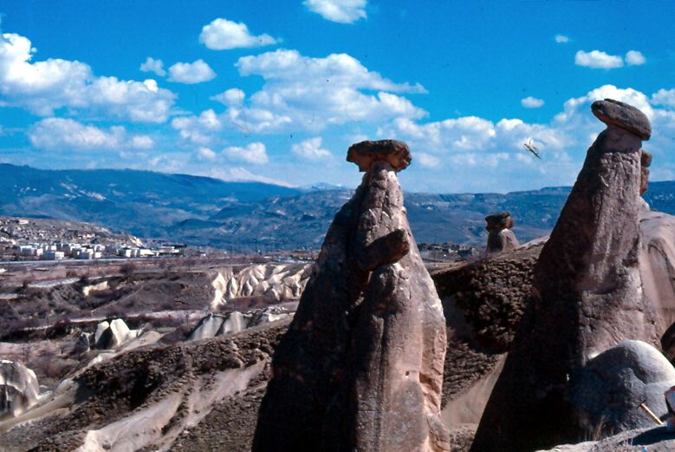
Cappadocian region is the place where nature and history come together most beautifully within the world. While geographic events are forming Peribacaları (fairy chimneys), during the historical period, humans had carried the signs of thousand years old civilizations with carving houses and churches within these earth pillars and decorating them with frisks.

DAY 2: Saturday 9 July

07:00 - Departure from the hotel after the breakfast.
Ihlara Canyon, Orhan Ağaçlı service area at the crossroads of Aksaray.
10:00 - Arrival at Çumra. Visit to Çatalhöyük. (245 km.)
13:00 - Back to Konya and lunch.
14:00 - Visit to Konya Mevlana Museum.
Free time
Dinner and stay at Hilton Hotel, Konya.

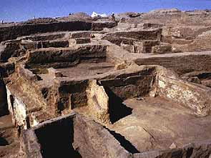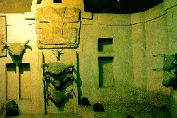
On the yellow plains of central Anatolia lie the remains of one of the oldest civilizations on earth. Called Çatalhöyük, the site ruins represent a village of 300 mud brick and plaster residences, based on a farming economy--in fact, the first farming community found to date. The site was occupied from about 6300-5500 bc, and its most striking and famous feature are the shrines, shrines dedicated to what has been called the "Mother Goddess." The residences were accessed through the roof, into main rooms, each about 6 x 4 m.

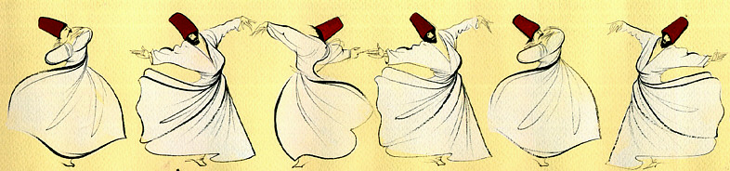

Mevlana Museum was once the cloister of Mevlâna Celaleddin-i Rumî, a great mystical philosopher of the 13th century, and the Sufi Order known as Whirling Dervishes (Mevlevi). The Mevlevi doctrine was based on music, dancing and poetry with its stress on the value of love and ecstasy. The museum houses the striking green-tiled mausoleum of Mevlana, his family, and outstanding members of the Mevlevi order, and ceremonial musical instruments and materials, handwritten books, carpets of the time. Every year, in the first half of December, this still active religious order holds a ceremony commemorating the Whirling Dervishes. The controlled, trance-like turning or sema of the white-robed men produces a fascinating performance.

DAY 3: Sunday 10 July
07:00 - Departure from the hotel after the breakfast.
15:30 - Arrival at Istanbul. (via Ankara-Bolu total 670 km)

